From the paper:

neuro feedback systems -> effective in aquiring the self-regulating stuff

1- how many timrs to we repeath the thing ? main focus of the study (one of)

2- is the impact immediate on sustained attention? (measuring the treatment effects and see if th effects are apparent in the short term)

we need to understand the relationship of system and attention

the conditioning effect of treatment freq and duration

Four hyps:

1. using for 10 min do better (fewer errors) in SART than non-users

2. users make fewer errors than non-users in SART

3. users have higher avg attenrion braiwave score than non-users

4. users self-report higher attention levels

method:

using single sensor and ear clip to reduce env sounds

why using that kind of control groups in calibration activity

two measures used:

SART score - survey based on ms

users are asked to press the spacebar when the numbers that weren't in their arget

some kind of concealing for the game??

so for each using group we have pre and posttest (SART number 3 - test (actual) - SART number 5)

exp design: 2 condition neuro between subject design

errors of ommision: not pressing the spacebar when a non-target number appears

errors of commision:

DVs: SART error of ommision, SART error of commision, avg brainwave attention scores, response to self-report surevetys

dicuss sampling strategy and whether we would have done it differently

IAT804 notes and stuff

Question of the study:

if a game-based neurofeedback application can effectively support people to improve their ability to self-regulate their attention used as an intervention in a single session

Methodolgy and design:

mixed method - between-subject experiment

IV(s):

Intervention/Control groups (between groups)

Assesment time point (Within group)

One group used the real feedback appllication - Contro group used a sham version. Mesures were administered in different times in the study

What we'll look up for:

Research problems

Data colletion methods

anlysis procedure

run the analysis

Interpret your results and write a discussion section

Tasks:

Read it - find research question and hypo and iv and dv

review data

create exlporatory plots for each exp

review the ouput files to find evidence to address each experiment

write a short results section (max three pages) structured by hypo. each hypo in a subsection + descriptive and inferential result to support ot refute the hypo + include graphs with error bars to show significant results

write short dicussion section -> synthesize the results to address the overarching research question, providing an assessment of the effectiveness of the neurofeedback application as it was used in this intervention

in discusison: include a short limitations section + no more than one page

write short conclusion providing the main contributions of the work + future work suggestions

1. Creating exploratory plots for the hyp.
   1. H1:

Descriptive stats: mean – standard error –

For descriptive we just use the inferential thing all over again and just report that (M = ? and SD = ?) and that’s it!

So here’s the first plot!:

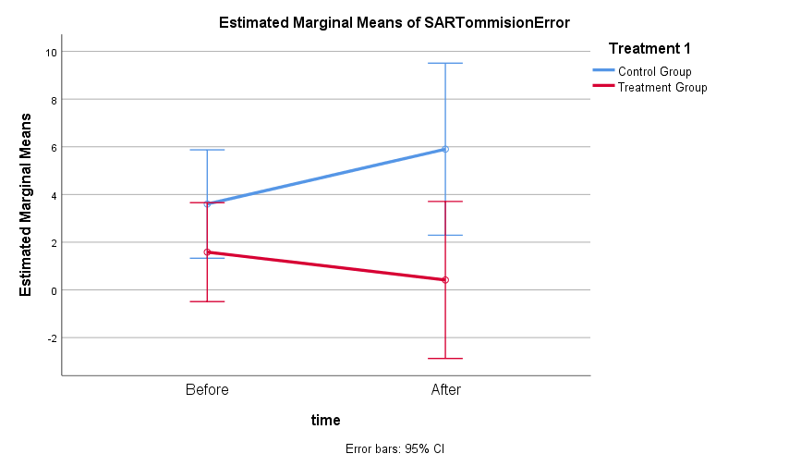

* Looking at tests of within-subject effects (meaning time) for time*treatment1:

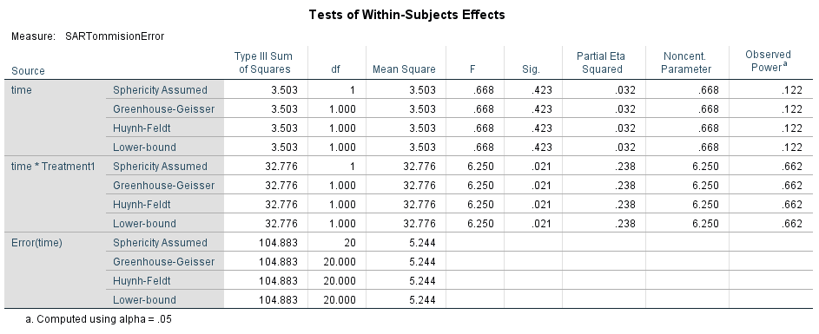

Looking at this we find that there is **significant change** for interaction (time*treatment1) so **we need to redo the stats for simple main effects**

**We also see this in between subject test data for the effect of treatment1 (aka group):**

|  |  |  |  |  |  |  |  |  |
| --- | --- | --- | --- | --- | --- | --- | --- | --- |
| **Tests of Between-Subjects Effects** | | | | | | | | |
| Measure: SARTommisionError | | | | | | | | |
| Transformed Variable: Average | | | | | | | | |
| Source | Type III Sum of Squares | df | Mean Square | F | Sig. | Partial Eta Squared | Noncent. Parameter | Observed Powera |
| Intercept | 180.341 | 1 | 180.341 | 9.878 | .005 | .331 | 9.878 | .848 |
| Treatment1 | 76.705 | 1 | 76.705 | 4.202 | .054 | .174 | 4.202 | .496 |
| Error | 365.125 | 20 | 18.256 |  |  |  |  |  |
| a. Computed using alpha = .05 | | | | | | | | |

**Which indicates that the treatment doesn’t have a critical effect!**

Our data is actually in wide format! Long format means the vars are in blah blah

We need to first convert it into long format

Then restructure …

We ran all those shits and we find out this (Which is in our second thing (Univariate analysis) that:

When we compare the pairwise comparisons for the first hypothesis and look at pairwise comparisons below:

Table 1 - P comparison for Group Variable

|  |  |  |  |  |  |  |
| --- | --- | --- | --- | --- | --- | --- |
| **Pairwise Comparisons** | | | | | | |
| Dependent Variable: Pre- Omission Number | | | | | | |
| (I) Treatment 1 | (J) Treatment 1 | Mean Difference (I-J) | Std. Error | Sig.b | 95% Confidence Interval for Differenceb | |
| Lower Bound | Upper Bound |
| control | treatment | 3.750* | 1.383 | .010 | .954 | 6.546 |
| treatment | control | -3.750* | 1.383 | .010 | -6.546 | -.954 |
| Based on estimated marginal means | | | | | | |
| *. The mean difference is significant at the .05 level. | | | | | | |
| b. Adjustment for multiple comparisons: Bonferroni. | | | | | | |

This table shows that there is a significant change in data between the two groups in the Omission SART score which means that the **treatment** independent variable is responsible for these changes (which suggests that our treatment is actually lowering the SART score of pre and post omission tests.

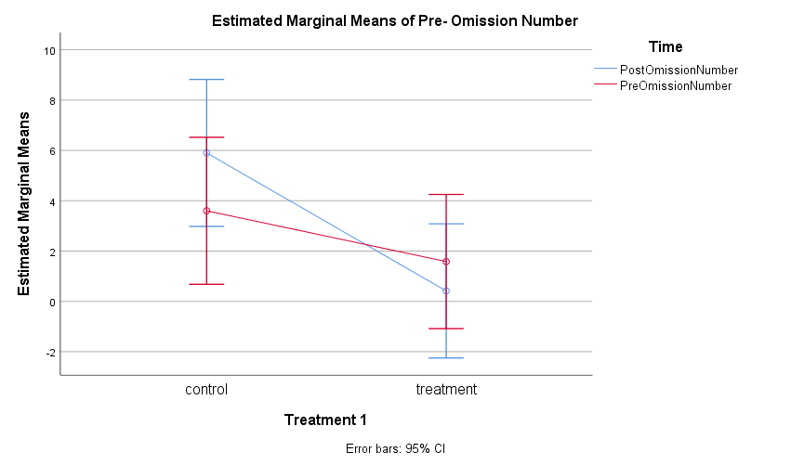

To calculate the effect size:

Mean square of (time*treatment1) = 32.776

Mean square error = 20.878

N = 30 (? Or 44 or 24)

Effect size is = 0.019 -> Which is a very small number and means that is not really that important???

Missing: histograms for mean – std. error and std. deviation and effect size (use excel or something!)

**H2:**

**Error of commission**

Histograms of precommision numbers:

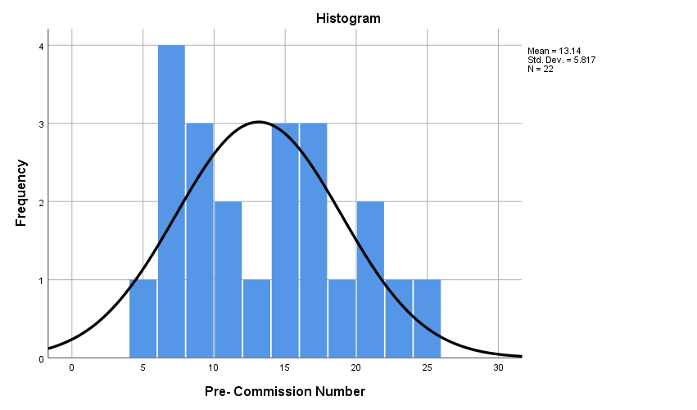

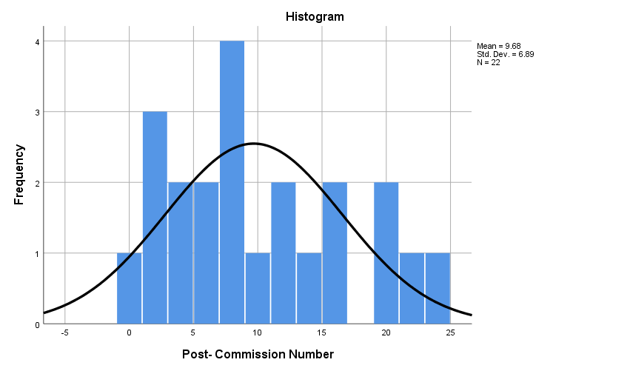

Here are some other descriptive stats:

|  |  |  |  |  |
| --- | --- | --- | --- | --- |
| **Descriptive Statistics** | | | | |
|  | Treatment 1 | Mean | Std. Deviation | N |
| Pre- Commission Number | control | 12.50 | 6.060 | 10 |
| treatment | 13.67 | 5.821 | 12 |
| Total | 13.14 | 5.817 | 22 |
| Post- Commission Number | control | 13.80 | 6.374 | 10 |
| treatment | 6.25 | 5.396 | 12 |
| Total | 9.68 | 6.890 | 22 |

For inferential:

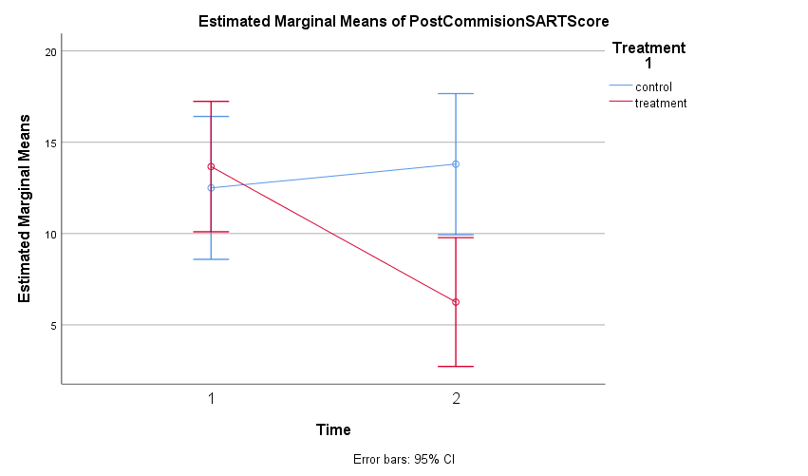

Which shows that the control group didn’t change quite much (actually their SART score of commission errors has become more)

Looking at the significance we can see:

|  |  |  |  |  |  |  |  |  |  |
| --- | --- | --- | --- | --- | --- | --- | --- | --- | --- |
| **Tests of Within-Subjects Effects** | | | | | | | | | |
| Measure: PostCommisionSARTScore | | | | | | | | | |
| Source | | Type III Sum of Squares | df | Mean Square | F | Sig. | Partial Eta Squared | Noncent. Parameter | Observed Powera |
| Time | Sphericity Assumed | 102.037 | 1 | 102.037 | 8.931 | .007 | .309 | 8.931 | .811 |
| Greenhouse-Geisser | 102.037 | 1.000 | 102.037 | 8.931 | .007 | .309 | 8.931 | .811 |
| Huynh-Feldt | 102.037 | 1.000 | 102.037 | 8.931 | .007 | .309 | 8.931 | .811 |
| Lower-bound | 102.037 | 1.000 | 102.037 | 8.931 | .007 | .309 | 8.931 | .811 |
| Time * Treatment1 | Sphericity Assumed | 207.219 | 1 | 207.219 | 18.137 | .000 | .476 | 18.137 | .982 |
| Greenhouse-Geisser | 207.219 | 1.000 | 207.219 | 18.137 | .000 | .476 | 18.137 | .982 |
| Huynh-Feldt | 207.219 | 1.000 | 207.219 | 18.137 | .000 | .476 | 18.137 | .982 |
| Lower-bound | 207.219 | 1.000 | 207.219 | 18.137 | .000 | .476 | 18.137 | .982 |
| Error(Time) | Sphericity Assumed | 228.508 | 20 | 11.425 |  |  |  |  |  |
| Greenhouse-Geisser | 228.508 | 20.000 | 11.425 |  |  |  |  |  |
| Huynh-Feldt | 228.508 | 20.000 | 11.425 |  |  |  |  |  |
| Lower-bound | 228.508 | 20.000 | 11.425 |  |  |  |  |  |
| a. Computed using alpha = .05 | | | | | | | | | |

|  |  |  |  |  |  |  |  |  |  |
| --- | --- | --- | --- | --- | --- | --- | --- | --- | --- |
| **Tests of Within-Subjects Contrasts** | | | | | | | | | |
| Measure: PostCommisionSARTScore | | | | | | | | | |
| Source | Time | Type III Sum of Squares | df | Mean Square | F | Sig. | Partial Eta Squared | Noncent. Parameter | Observed Powera |
| Time | Level 1 vs. Level 2 | 204.074 | 1 | 204.074 | 8.931 | .007 | .309 | 8.931 | .811 |
| Time * Treatment1 | Level 1 vs. Level 2 | 414.438 | 1 | 414.438 | 18.137 | .000 | .476 | 18.137 | .982 |
| Error(Time) | Level 1 vs. Level 2 | 457.017 | 20 | 22.851 |  |  |  |  |  |
| a. Computed using alpha = .05 | | | | | | | | | |

**We can see that both time and time*treatment1(or group) are significan- both sig < 0.05 -> we need to run univariant ANOVA to check to see what variable is doing what!**

**And for between-subject effect:**

|  |  |  |  |  |  |  |  |  |
| --- | --- | --- | --- | --- | --- | --- | --- | --- |
| **Tests of Between-Subjects Effects** | | | | | | | | |
| Measure: PostCommisionSARTScore | | | | | | | | |
| Transformed Variable: Average | | | | | | | | |
| Source | Type III Sum of Squares | df | Mean Square | F | Sig. | Partial Eta Squared | Noncent. Parameter | Observed Powera |
| Intercept | 2912.700 | 1 | 2912.700 | 100.394 | .000 | .834 | 100.394 | 1.000 |
| Treatment1 | 55.564 | 1 | 55.564 | 1.915 | .182 | .087 | 1.915 | .261 |
| Error | 580.254 | 20 | 29.013 |  |  |  |  |  |
| a. Computed using alpha = .05 | | | | | | | | |

**So we can clearly see that group(or treatment1) didn’t have a significant effect!**

Univariant ANOVA for this one:

After running it we have:

Looking at pairwise comparisons:

|  |  |  |  |  |  |  |
| --- | --- | --- | --- | --- | --- | --- |
| **Pairwise Comparisons** | | | | | | |
| Dependent Variable: Pre- Commission Number | | | | | | |
| (I) Treatment 1 | (J) Treatment 1 | Mean Difference (I-J) | Std. Error | Sig.a | 95% Confidence Interval for Differencea | |
| Lower Bound | Upper Bound |
| control | treatment | 3.192 | 1.784 | .081 | -.414 | 6.798 |
| treatment | control | -3.192 | 1.784 | .081 | -6.798 | .414 |
| Based on estimated marginal means | | | | | | |
| a. Adjustment for multiple comparisons: Bonferroni. | | | | | | |

Which shows no sig for group – means group didn’t have an effect on commisionError SART scores

|  |  |  |  |  |  |  |
| --- | --- | --- | --- | --- | --- | --- |
| **Pairwise Comparisons** | | | | | | |
| Dependent Variable: Pre- Commission Number | | | | | | |
| (I) Ctime | (J) Ctime | Mean Difference (I-J) | Std. Error | Sig.a | 95% Confidence Interval for Differencea | |
| Lower Bound | Upper Bound |
| PostCommissionNumber | PreCommissionNumber | -3.058 | 1.784 | .094 | -6.664 | .548 |
| PreCommissionNumber | PostCommissionNumber | 3.058 | 1.784 | .094 | -.548 | 6.664 |
| Based on estimated marginal means | | | | | | |
| a. Adjustment for multiple comparisons: Bonferroni. | | | | | | |

Which shows the same is also true about time and pre and post commission don’t have significant differences

|  |  |  |  |  |  |  |  |
| --- | --- | --- | --- | --- | --- | --- | --- |
| **Pairwise Comparisons** | | | | | | | |
| Dependent Variable: Pre- Commission Number | | | | | | | |
| Treatment 1 | (I) Ctime | (J) Ctime | Mean Difference (I-J) | Std. Error | Sig.b | 95% Confidence Interval for Differenceb | |
| Lower Bound | Upper Bound |
| control | PostCommissionNumber | PreCommissionNumber | 1.300 | 2.635 | .625 | -4.026 | 6.626 |
| PreCommissionNumber | PostCommissionNumber | -1.300 | 2.635 | .625 | -6.626 | 4.026 |
| treatment | PostCommissionNumber | PreCommissionNumber | -7.417* | 2.406 | .004 | -12.279 | -2.554 |
| PreCommissionNumber | PostCommissionNumber | 7.417* | 2.406 | .004 | 2.554 | 12.279 |
| Based on estimated marginal means | | | | | | | |
| *. The mean difference is significant at the .05 level. | | | | | | | |
| b. Adjustment for multiple comparisons: Bonferroni. | | | | | | | |

|  |  |  |  |  |  |  |  |  |  |
| --- | --- | --- | --- | --- | --- | --- | --- | --- | --- |
| **Univariate Tests** | | | | | | | | | |
| Dependent Variable: Pre- Commission Number | | | | | | | | | |
| Treatment 1 | | Sum of Squares | df | Mean Square | F | Sig. | Partial Eta Squared | Noncent. Parameter | Observed Powera |
| control | Contrast | 8.450 | 1 | 8.450 | .243 | .625 | .006 | .243 | .077 |
| Error | 1389.017 | 40 | 34.725 |  |  |  |  |  |
| treatment | Contrast | 330.042 | 1 | 330.042 | 9.504 | .004 | .192 | 9.504 | .853 |
| Error | 1389.017 | 40 | 34.725 |  |  |  |  |  |
| Each F tests the simple effects of Ctime within each level combination of the other effects shown. These tests are based on the linearly independent pairwise comparisons among the estimated marginal means. | | | | | | | | | |
| a. Computed using alpha = .05 | | | | | | | | | |

**It’s for group(treatment1*time) which shows that for treatment group there is a sig diff between pre and post-test**

using (treatment*time) this time with groups being the changed variable we see that:

|  |  |  |  |  |  |  |  |
| --- | --- | --- | --- | --- | --- | --- | --- |
| **Pairwise Comparisons** | | | | | | | |
| Dependent Variable: Pre- Commission Number | | | | | | | |
| Ctime | (I) Treatment 1 | (J) Treatment 1 | Mean Difference (I-J) | Std. Error | Sig.b | 95% Confidence Interval for Differenceb | |
| Lower Bound | Upper Bound |
| PostCommissionNumber | control | treatment | 7.550* | 2.523 | .005 | 2.451 | 12.649 |
| treatment | control | -7.550* | 2.523 | .005 | -12.649 | -2.451 |
| PreCommissionNumber | control | treatment | -1.167 | 2.523 | .646 | -6.266 | 3.933 |
| treatment | control | 1.167 | 2.523 | .646 | -3.933 | 6.266 |
| Based on estimated marginal means | | | | | | | |
| *. The mean difference is significant at the .05 level. | | | | | | | |
| b. Adjustment for multiple comparisons: Bonferroni. | | | | | | | |

Which shows that there is a significant diff between score points of treatment and control group for the post-test which actually shows that the treatment group has gotten better after the mindful thing

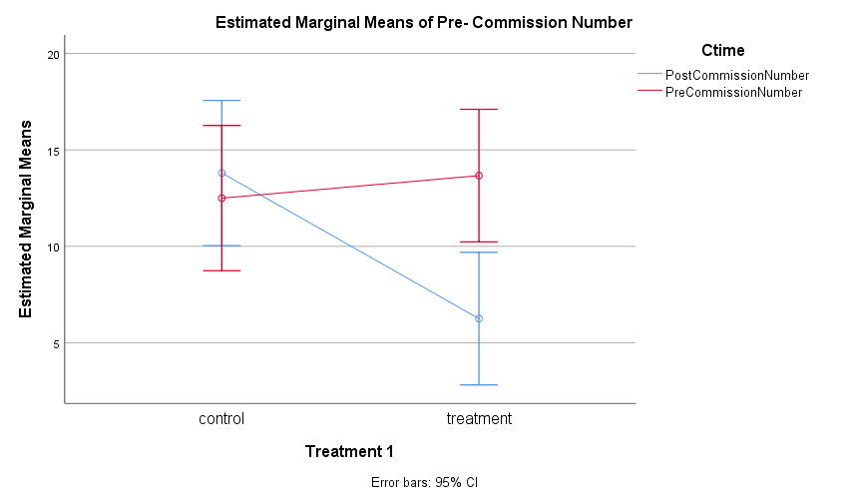

This one is the plot and shows the thing that we just said!

To calculate the effect-size:

mean square time*group - mean square error)/(mean square time*group + ((n-1)*mean square error

mean square time*group = 207.219

mean square error = 34.725

* 172.494/(1007.025 + 207.219) = 172.494/1214.244 = 0.14

Again the effect is quite small and non-important :/

**H3:**

Running a 2*10 anova:

Descriptive stuff:

For all the scores we have this histogram:

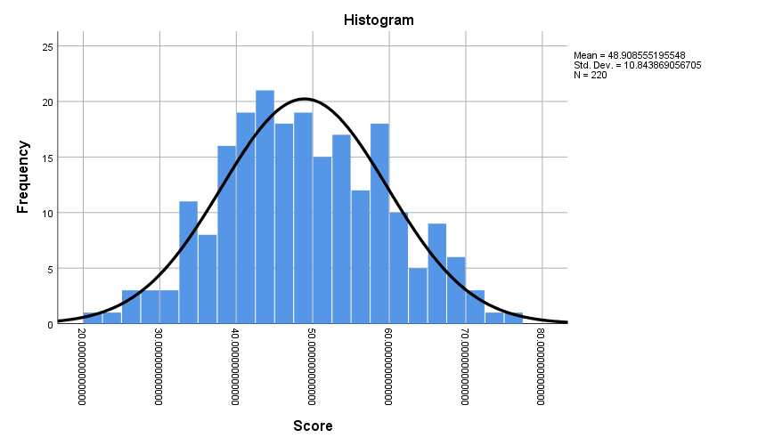

But we can also use one for scores of each minute! Whatever that works the best!

We have the detailed histogram of each min if we need it!

**Now looking at the ANOVA results:**

We see that:

|  |  |  |  |  |  |  |  |  |  |
| --- | --- | --- | --- | --- | --- | --- | --- | --- | --- |
| **Tests of Within-Subjects Effects** | | | | | | | | | |
| Measure: AvgAttentionBrainwaveIndex | | | | | | | | | |
| Source | | Type III Sum of Squares | df | Mean Square | F | Sig. | Partial Eta Squared | Noncent. Parameter | Observed Powera |
| TimeMin | Sphericity Assumed | 632.256 | 9 | 70.251 | 1.152 | .329 | .054 | 10.366 | .559 |
| Greenhouse-Geisser | 632.256 | 3.927 | 160.993 | 1.152 | .338 | .054 | 4.523 | .343 |
| Huynh-Feldt | 632.256 | 5.251 | 120.406 | 1.152 | .338 | .054 | 6.048 | .406 |
| Lower-bound | 632.256 | 1.000 | 632.256 | 1.152 | .296 | .054 | 1.152 | .176 |
| TimeMin * Treatment | Sphericity Assumed | 210.561 | 9 | 23.396 | .384 | .942 | .019 | 3.452 | .188 |
| Greenhouse-Geisser | 210.561 | 3.927 | 53.616 | .384 | .816 | .019 | 1.506 | .133 |
| Huynh-Feldt | 210.561 | 5.251 | 40.099 | .384 | .867 | .019 | 2.014 | .149 |
| Lower-bound | 210.561 | 1.000 | 210.561 | .384 | .543 | .019 | .384 | .091 |
| Error(TimeMin) | Sphericity Assumed | 10978.839 | 180 | 60.994 |  |  |  |  |  |
| Greenhouse-Geisser | 10978.839 | 78.544 | 139.779 |  |  |  |  |  |
| Huynh-Feldt | 10978.839 | 105.021 | 104.540 |  |  |  |  |  |
| Lower-bound | 10978.839 | 20.000 | 548.942 |  |  |  |  |  |
| a. Computed using alpha = .05 | | | | | | | | | |

Which means not time and nor interaction have sig effects

So we need to report the main effects using the **Tests of Within-Subjects Effects:**

**No significant time or treatment or interaction effect here!**

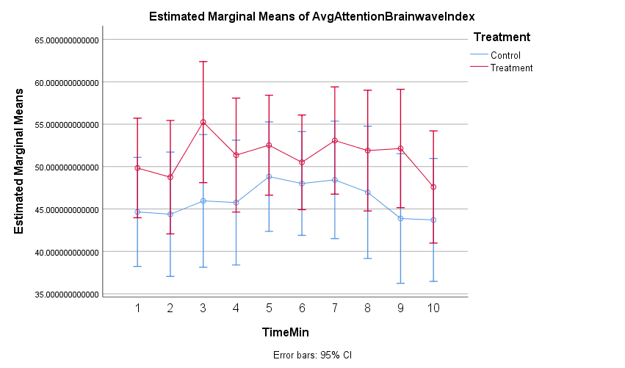

**Brainwave index in treatment group has a higher avg value than the treatment group during the whole experiment … but there are no significant effects to show that these are caused by either passing of time or using the treatment (meaning that there is not enough diff between chance causing this and treatment causing it)**

**H4:**

Running the descriptive we get this for the self report score:

|  |  |  |  |  |  |
| --- | --- | --- | --- | --- | --- |
| **Descriptives** | | | | | |
|  | Treatment | | | Statistic | Std. Error |
| Survey 1 | control | Mean | | 4.70 | .746 |
| 95% Confidence Interval for Mean | Lower Bound | 3.01 |  |
| Upper Bound | 6.39 |  |
| 5% Trimmed Mean | | 4.56 |  |
| Median | | 4.50 |  |
| Variance | | 5.567 |  |
| Std. Deviation | | 2.359 |  |
| Minimum | | 2 |  |
| Maximum | | 10 |  |
| Range | | 8 |  |
| Interquartile Range | | 3 |  |
| Skewness | | 1.336 | .687 |
| Kurtosis | | 1.968 | 1.334 |
| treatmen | Mean | | 5.33 | .801 |
| 95% Confidence Interval for Mean | Lower Bound | 3.57 |  |
| Upper Bound | 7.10 |  |
| 5% Trimmed Mean | | 5.31 |  |
| Median | | 5.00 |  |
| Variance | | 7.697 |  |
| Std. Deviation | | 2.774 |  |
| Minimum | | 1 |  |
| Maximum | | 10 |  |
| Range | | 9 |  |
| Interquartile Range | | 5 |  |
| Skewness | | .199 | .637 |
| Kurtosis | | -.774 | 1.232 |
| Survey 2 | control | Mean | | 5.80 | .742 |
| 95% Confidence Interval for Mean | Lower Bound | 4.12 |  |
| Upper Bound | 7.48 |  |
| 5% Trimmed Mean | | 5.78 |  |
| Median | | 5.50 |  |
| Variance | | 5.511 |  |
| Std. Deviation | | 2.348 |  |
| Minimum | | 2 |  |
| Maximum | | 10 |  |
| Range | | 8 |  |
| Interquartile Range | | 3 |  |
| Skewness | | .106 | .687 |
| Kurtosis | | .044 | 1.334 |
| treatmen | Mean | | 6.42 | .723 |
| 95% Confidence Interval for Mean | Lower Bound | 4.83 |  |
| Upper Bound | 8.01 |  |
| 5% Trimmed Mean | | 6.52 |  |
| Median | | 7.50 |  |
| Variance | | 6.265 |  |
| Std. Deviation | | 2.503 |  |
| Minimum | | 2 |  |
| Maximum | | 9 |  |
| Range | | 7 |  |
| Interquartile Range | | 5 |  |
| Skewness | | -.571 | .637 |
| Kurtosis | | -1.177 | 1.232 |
| Survey 3 | control | Mean | | 4.00 | .715 |
| 95% Confidence Interval for Mean | Lower Bound | 2.38 |  |
| Upper Bound | 5.62 |  |
| 5% Trimmed Mean | | 3.94 |  |
| Median | | 4.50 |  |
| Variance | | 5.111 |  |
| Std. Deviation | | 2.261 |  |
| Minimum | | 1 |  |
| Maximum | | 8 |  |
| Range | | 7 |  |
| Interquartile Range | | 4 |  |
| Skewness | | .144 | .687 |
| Kurtosis | | -.546 | 1.334 |
| treatmen | Mean | | 4.33 | .810 |
| 95% Confidence Interval for Mean | Lower Bound | 2.55 |  |
| Upper Bound | 6.12 |  |
| 5% Trimmed Mean | | 4.20 |  |
| Median | | 4.00 |  |
| Variance | | 7.879 |  |
| Std. Deviation | | 2.807 |  |
| Minimum | | 1 |  |
| Maximum | | 10 |  |
| Range | | 9 |  |
| Interquartile Range | | 4 |  |
| Skewness | | 1.040 | .637 |
| Kurtosis | | .355 | 1.232 |

And these:

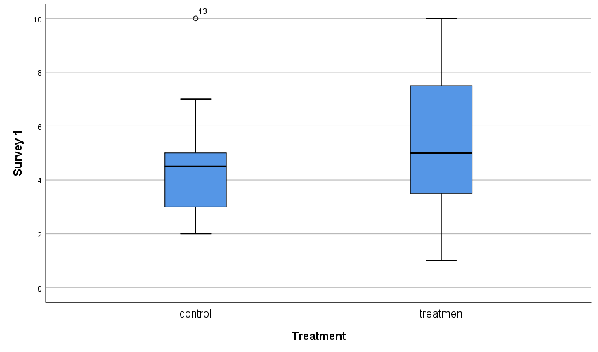

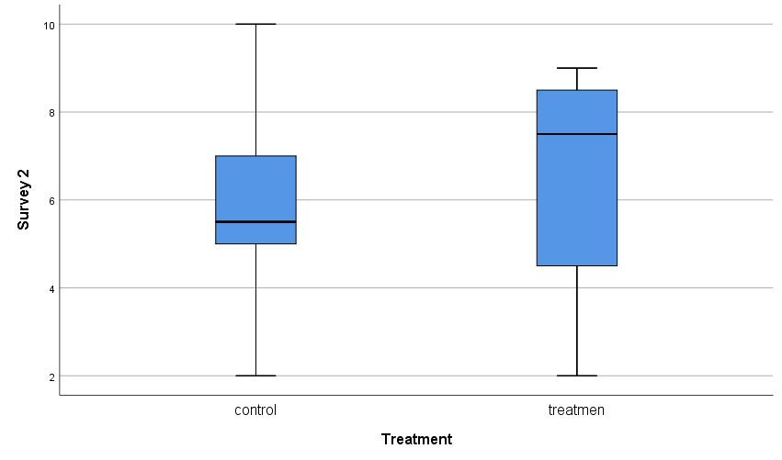

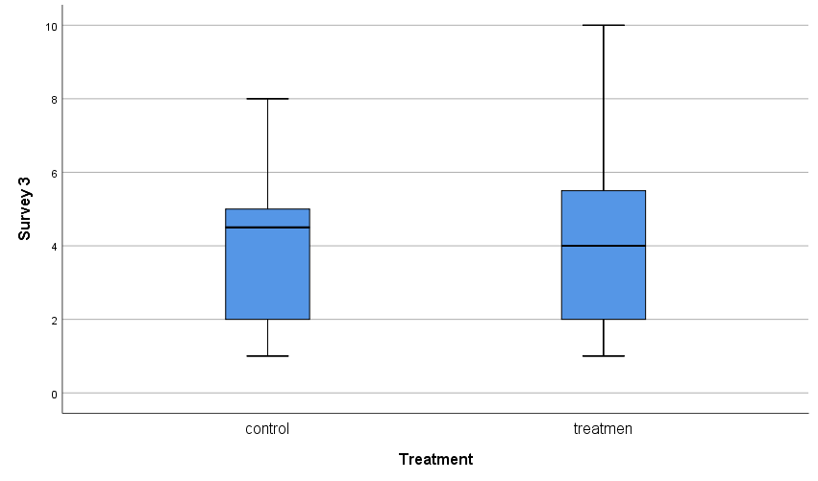

And we see that in almost all of them (except the last) the avg of scores are better

**Running anova:**

For within subjects we see:

|  |  |  |  |  |  |  |  |  |  |
| --- | --- | --- | --- | --- | --- | --- | --- | --- | --- |
| **Tests of Within-Subjects Effects** | | | | | | | | | |
| Measure: AttentionSelfReportScore | | | | | | | | | |
| Source | | Type III Sum of Squares | df | Mean Square | F | Sig. | Partial Eta Squared | Noncent. Parameter | Observed Powera |
| timeSurvey | Sphericity Assumed | 41.340 | 2 | 20.670 | 3.424 | .042 | .146 | 6.848 | .610 |
| Greenhouse-Geisser | 41.340 | 1.815 | 22.779 | 3.424 | .048 | .146 | 6.214 | .580 |
| Huynh-Feldt | 41.340 | 2.000 | 20.670 | 3.424 | .042 | .146 | 6.848 | .610 |
| Lower-bound | 41.340 | 1.000 | 41.340 | 3.424 | .079 | .146 | 3.424 | .421 |
| timeSurvey * Treatment | Sphericity Assumed | .310 | 2 | .155 | .026 | .975 | .001 | .051 | .054 |
| Greenhouse-Geisser | .310 | 1.815 | .171 | .026 | .966 | .001 | .047 | .053 |
| Huynh-Feldt | .310 | 2.000 | .155 | .026 | .975 | .001 | .051 | .054 |
| Lower-bound | .310 | 1.000 | .310 | .026 | .874 | .001 | .026 | .053 |
| Error(timeSurvey) | Sphericity Assumed | 241.478 | 40 | 6.037 |  |  |  |  |  |
| Greenhouse-Geisser | 241.478 | 36.297 | 6.653 |  |  |  |  |  |
| Huynh-Feldt | 241.478 | 40.000 | 6.037 |  |  |  |  |  |
| Lower-bound | 241.478 | 20.000 | 12.074 |  |  |  |  |  |
| a. Computed using alpha = .05 | | | | | | | | | |

We see that the interaction doesn’t have any effect – but we see that timeSurvey has the significant effect, meaning that based on this:

|  |  |  |  |  |  |  |  |  |  |
| --- | --- | --- | --- | --- | --- | --- | --- | --- | --- |
| **Tests of Within-Subjects Contrasts** | | | | | | | | | |
| Measure: AttentionSelfReportScore | | | | | | | | | |
| Source | timeSurvey | Type III Sum of Squares | df | Mean Square | F | Sig. | Partial Eta Squared | Noncent. Parameter | Observed Powera |
| timeSurvey | Level 1 vs. Level 3 | 15.764 | 1 | 15.764 | 1.420 | .247 | .066 | 1.420 | .206 |
| Level 2 vs. Level 3 | 82.256 | 1 | 82.256 | 8.820 | .008 | .306 | 8.820 | .806 |
| timeSurvey * Treatment | Level 1 vs. Level 3 | .491 | 1 | .491 | .044 | .836 | .002 | .044 | .055 |
| Level 2 vs. Level 3 | .438 | 1 | .438 | .047 | .831 | .002 | .047 | .055 |
| Error(timeSurvey) | Level 1 vs. Level 3 | 222.100 | 20 | 11.105 |  |  |  |  |  |
| Level 2 vs. Level 3 | 186.517 | 20 | 9.326 |  |  |  |  |  |
| a. Computed using alpha = .05 | | | | | | | | | |

Which shows that between post intervention (timepoint#2) and post-SART(timepoint#3) there is a significant diff between the two groups (which means what? :/)

The pairwise comparison of time alse supports this claim:

|  |  |  |  |  |  |  |
| --- | --- | --- | --- | --- | --- | --- |
| **Pairwise Comparisons** | | | | | | |
| Measure: AttentionSelfReportScore | | | | | | |
| (I) timeSurvey | (J) timeSurvey | Mean Difference (I-J) | Std. Error | Sig.b | 95% Confidence Interval for Differenceb | |
| Lower Bound | Upper Bound |
| 1 | 2 | -1.092 | .851 | .642 | -3.314 | 1.131 |
| 3 | .850 | .713 | .742 | -1.014 | 2.714 |
| 2 | 1 | 1.092 | .851 | .642 | -1.131 | 3.314 |
| 3 | 1.942* | .654 | .023 | .234 | 3.650 |
| 3 | 1 | -.850 | .713 | .742 | -2.714 | 1.014 |
| 2 | -1.942* | .654 | .023 | -3.650 | -.234 |
| Based on estimated marginal means | | | | | | |
| *. The mean difference is significant at the .05 level. | | | | | | |
| b. Adjustment for multiple comparisons: Bonferroni. | | | | | | |

And here’s the final graph:

